# Exercise: REST Services and AJAX

Problems for exercises and homework for the ["JavaScript Applications" course @ SoftUni](https://softuni.bg/courses/js-applications). Submit your solutions in the SoftUni Page - <https://softuni.bg/trainings/2347/js-apps-july-2019#lesson-11778>

## Bus Stop

Write a JS program that displays arrival times for all buses by a given bus stop ID when a button is clicked. Use the skeleton from the provided resources.

When the button with ID **'submit'** is clicked, the name of the bus stop appears and the list bellow gets filled with all the buses that are expected and their time of arrival. Take the **value** of the input field with id **'stopId'**. Submit a GET request to https://judgetests.firebaseio.com/businfo/{*stopId*}.json (replace the highlighted part with the correct value) and parse the response. You will receive a JSON object in the format:

stopId: {

name: stopName,

buses: { busId: time, … }

}

Place the name property as text inside the div with ID **'stopName'** and each bus as a list item with text:

"Bus {busId} arrives in {time}"

Replace all highlighted parts with the relevant value from the response. If the request is not successful, or the information is not in the expected format, display **"Error"** as stopName and nothing in the list. The list should be cleared before every request is sent.

### Examples

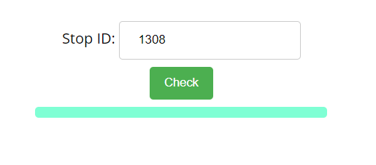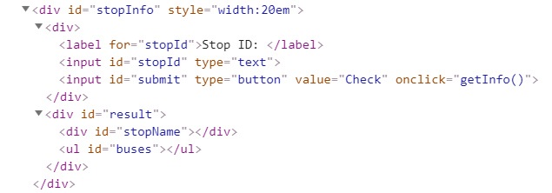

When the button is clicked, the results are displayed in the corresponding elements:

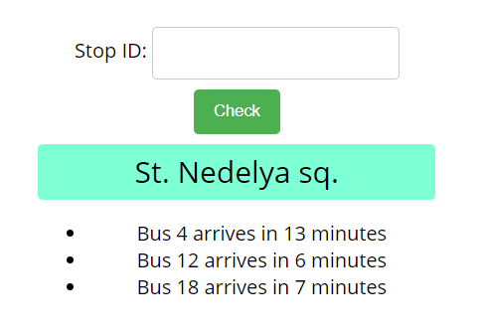

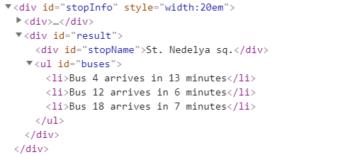

If an error occurs, the stop name changes to Error:

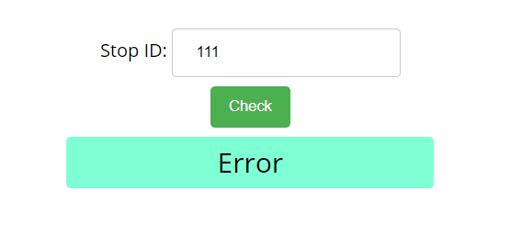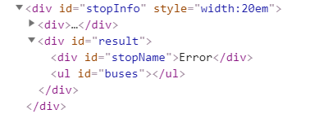

### Hints

The webhost will respond with valid data to IDs 1287, 1308, 1327 and 2334.

## Bus Schedule

Write a JS program that tracks the progress of a bus on it’s route and announces it inside an info box. The program should display which is the upcoming stop and once the bus arrives, to request from the server the name of the next one. Use the skeleton from the provided resources.

The bus has two states – **moving** and **stopped**. When it is **stopped**, only the button “**Depart**” is **enabled**, while the info box shows the name of the **current** stop. When it is **moving**, only the button “**Arrive**” is **enabled**, while the info box shows the name of the **upcoming** stop. Initially, the info box shows "**Not Connected**" and the "**Arrive**" button is **disabled**. The ID of the first stop is "**depot**".

When the "**Depart**" button is clicked, make a GET request to the server with the ID of the current stop to address https://judgetests.firebaseio.com/schedule/{currentId}.json (replace the highlighted part with the relevant value). As a response, you will receive a JSON object in the following format:

stopId {

name: stopName,

next: nextStopId

}

Update the info box with the information from the response, disable the “Depart” button and enable the “Arrive” button. The info box text should look like this (replace the highlighted part with the relevant value):

Next stop {stopName}

When the "**Arrive**" button is clicked, update the text, disable the “Arrive” button and enable the “Depart” button. The info box text should look like this (replace the highlighted part with the relevant value):

Arriving at {stopName}

Clicking the buttons successfully will cycle through the entire schedule. If invalid data is received, show "**Error**" inside the info box and **disable** both buttons.

### Examples

Initially, the info box shows “Not Connected” and the arrive button is disabled.

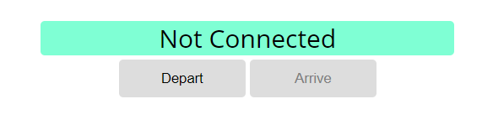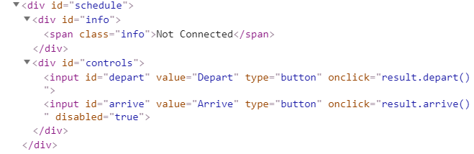

When Depart is clicked, a request is made with the first ID. The info box is updated with the new information and the buttons are changed: 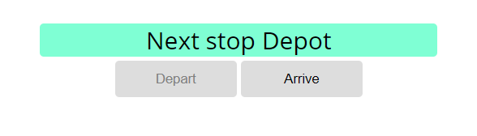

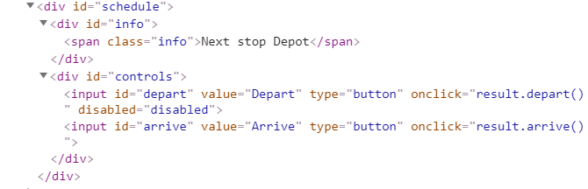

Clicking Arrive, changes the info box and swaps the buttons. This allows Depart to be clicked again, which makes a new request and updates the information:

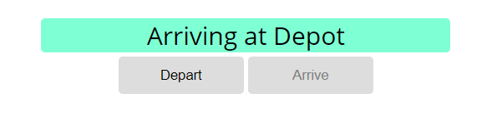

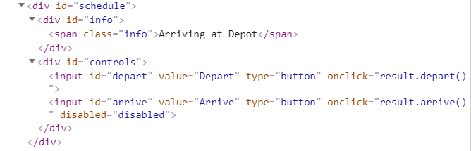

## Phonebook

Write a JS program that can load, create and delete entries from a Phonebook. You will be given an HTML template to which you must bind the needed functionality.

Use the skeleton from the provided resources.

When the [Load] button is clicked, a GET request should be made to the server to get all phonebook entries. Each received entry should be in a li inside the ul with id="phonebook" in the following format with text "<person>: <phone> " and a [Delete] button attached. Pressing the [Delete] button should send a DELETE request to the server and delete the entry.

The received response will be an object in the following format:  
{<key>:{person:<person>, phone:<phone>}, <key2>:{person:<person2>, phone:<phone2>,…} where <key> is an unique key given by the server and <person> and <phone> are the actual values.

When the [Create] button is clicked, a new POST request should be made to the server with the information from the Person and Phone textboxes, the Person and Phone textboxes should be cleared and the Phonebook should be automatically reloaded (like if the [Load] button was pressed).

The data sent on a POST request should be a valid JSON object, containing properties person and phone. Example format:   
{

"person": "<person>",

"phone": "<phone>"  
}

The url to which your program should make requests is:

**'https://phonebook-nakov.firebaseio.com/phonebook'**

GET and POST requests should go to https://phonebook-nakov.firebaseio.com/phonebook.json, while DELETE requests should go to https://phonebook-nakov.firebaseio.com/phonebook/<key>.json, where <key> is the unique key of the entry (you can find out the key from the key property in the GET request)

**You may create your own app** in Firebase.

### Screenshots:

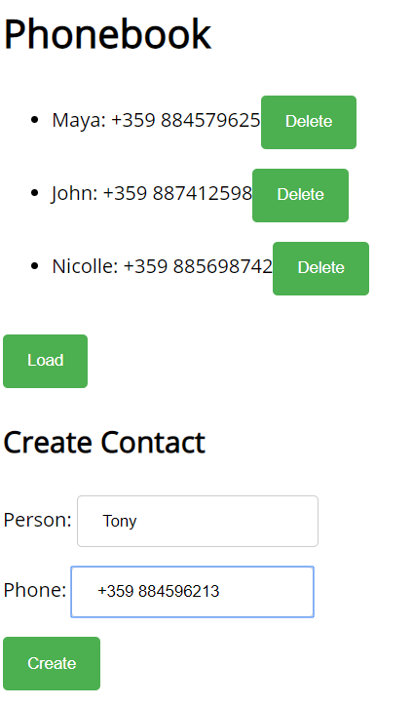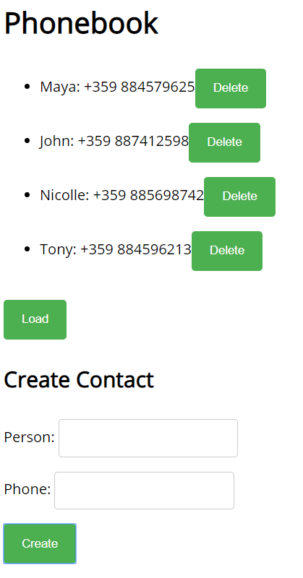

## Messenger

Write a JS program that records and displays messages. The user can post a message, supplying a name and content and retrieve all currently recorded messages.  
Use the skeleton from the provided resources

**Firebase url** for the requests - <https://rest-messanger.firebaseio.com/messanger>

When [**Send**] **button** is clicked you should create a **new** **object** and send a **post** **request** to the firebase url. Use the following message structure:

{

author: authorName,

content: msgText,

}

The key associated with each message object is not important - when making a POST request with the message object as parameter, Firebase will automatically assign a random key.

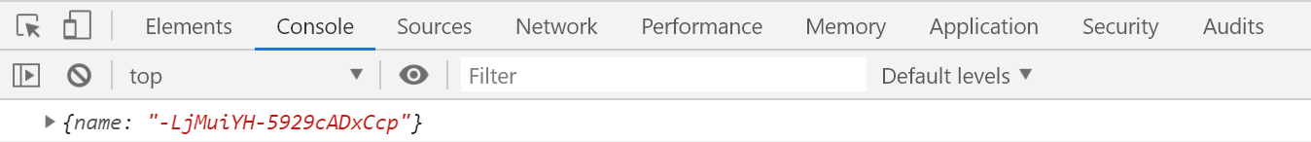

If you click over [**Refresh**] **button** you should **get all** messages with **GET** **request** and display them into the textarea. Use the following message format:  
"**{author}: {message}**"

### Examples

